BAN 602 Case 4

Compensation for Sales Professionals

Managerial Report

Megh Dave

Manideep Elasagaram

Abhinandan Somachetty

September 28, 2022

1. Summary of salaries of all individuals irrespective of their position and experience: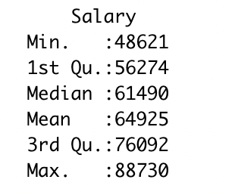

As can be seen from the output, the salaries of all individuals range from a minimum of 48621 to a maximum of 88730 with a mean salary of 64925. The highest salary is almost twice (1.8 times) the minimum salary.

Descriptive statistics to summarize the data only by experience irrespective of position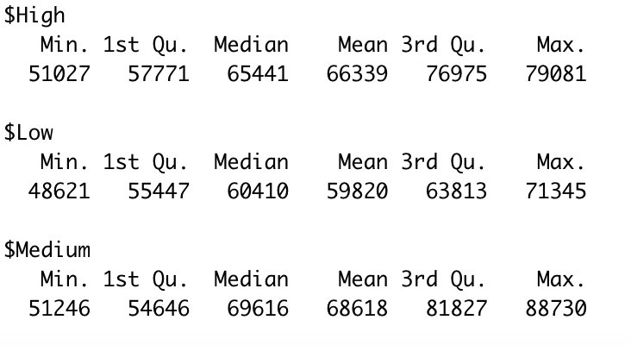

As a general trend, individuals with low experience have lower salaries than professionals with medium or high experience. Surprisingly, individuals with 11-20 years of experience earn more than highly experienced professionals who have 21+ years of experience. The lowest salary of all salespersons belongs to the low experience group and the highest salary is that of an individual who has medium experience.

75th percentile of the medium experience group (81827) is almost 3000 more than the maximum of the highest experience group (79081). Also, the mean of the medium experience individuals (68618) is nearly 5000 more than the third quartile (75th Percentile) of salespersons having low experience (63813). Compared with the mean of the entire data, more than 75% of individuals having low experience earn less than the average salary of all salespersons.

From the data, it can be said that people having low experience generally earn less, however having 11-20 years of experience is more valued than having 21+ years of experience for salespersons in the greater San Francisco area.

Descriptive statistics to summarize the data only by position irrespective of experience: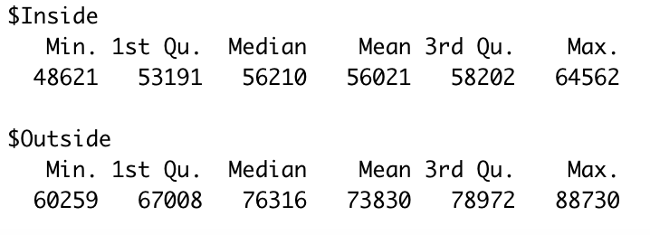

As an overall trend, individuals employed outside have higher salaries than those employed inside. More than 75% of salespersons employed outside earn more than the individual who earns maximum among those employed inside.

This is not a controlled experiment as no attempts are made to control the factors of position, experience, or salary. It is just an observational study as it is a survey.

5. We must test for any significant differences in annual salary due to position, years of experience, and the interaction of those two. For this, we will use the factorial experiment since we want to draw simultaneous conclusions about the factors of position and years of experience and also their interaction.

Step 1: Developing the hypothesis:

Ho: There is no significant difference in the mean annual salary of all salespersons due to position, years of experience, and interaction

Ha: There is a significant difference in the mean annual salary of all salespersons due to position, years of experience, and interaction

Step 2: Level of significance: α = 0.05

Step 3: Computing test statistic using ANOVA: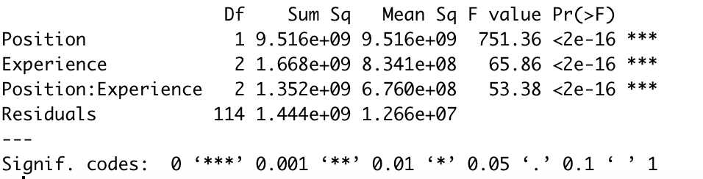

Step 4: Computing p-value:

* Position:

P-value = 0.000 < α = 0.05. Therefore, we reject Ho and conclude that the mean salary differs by position.

* Experience:

P-value = 0.000 < α = 0.05. Again, we reject Ho and establish that mean salary differs by experience as well.

* Interaction:

P-value = 0.000 < α = 0.05. We accept the Ha which means that there is a significant difference in mean salaries due to the interaction of position and experience of salespersons.

Thus, we can conclude that individuals employed in inside or outside sales positions and their level of experience, i.e., low, medium, or high along with the interaction of position and experience have a significant difference in the annual salary of the sales positions.